Adventure Education
Fishing
Spincast is the simplest gear with a reel.
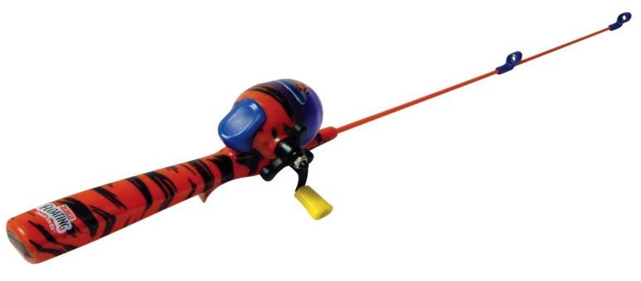

Spincast gear is the appropriate choice for most beginning anglers. The fishing line comes out of a hole in the reel cover. During the cast, the thumb is used to release the line, and the index finger is used for control. Spincast gear is used to cast light to medium size lures. Spincast gear is not the best choice for using very light fishing line or heavy fishing line. Line on a spincast rod must come out of the hole in the cone and go through each of the guides on the rod.

Spinning reel gear can cast farther than spincast gear.
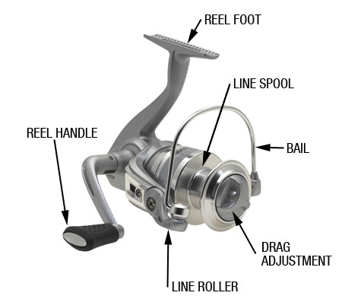
The fishing line in a spinning reel is exposed, and the index finger is used to release the line and to control the line. The first guide of a spinning rod is large. Various spinning gear is used for casting very light to heavy lures. Line on a spinning rig comes off the spool of line, under the wire bail, and through each guide.
Baitcasting gear has more control and more power than spinning gear.
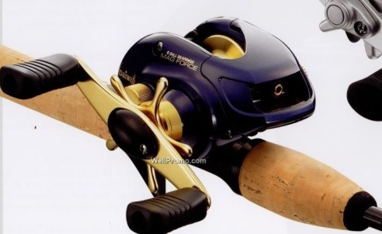
In a casting reel, the fishing line rotates the spool as the line comes off the spool. During the cast, the thumb is used to release the line and to slow and stop the line. Bait casting gear can cast moderate to very heavy weights farther than other reels.

A fly rod works differently than other rods.
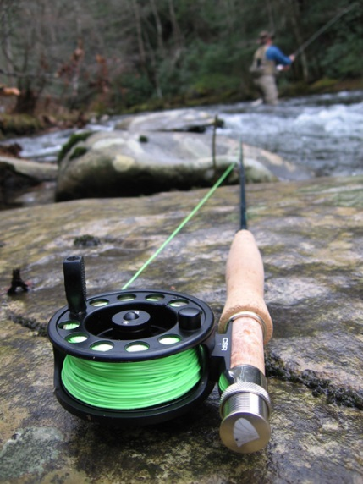
The fly rod casts the line instead of casting the lure. The heavy fly line is used for the casting, and a leader, usually tapered monofilament, connects the fly line to the fly. The fly rod casts very light lures typically made of feathers, fur or fibers that cast out with the line. Fly fishing is not difficult, but it normally takes training to learn the proper technique.
Terminal tackle is the tackle between the fish and the reel.
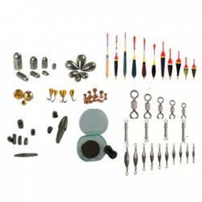
Hooks keep fish attached to the fishing line.
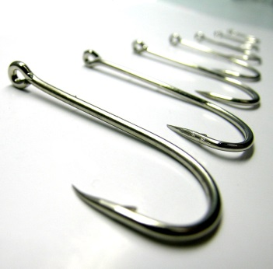
Hooks must be kept sharp. Hooks come in many sizes and types. The local bait and tackle store can provide recommendations of hook type and size for the species targeted and the bait used. The size fishing line or leader used depends on the size hook being used. If fish are nibbling, but are not getting hooked; a smaller hook should be used.
Snaps and Swivels
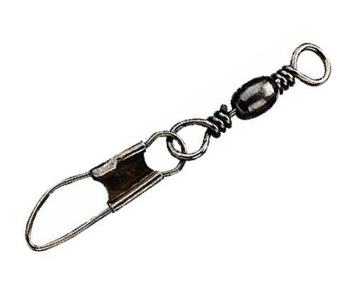
Most hooks and lures are more effective without snaps or snap-swivels attached Crank baits (wobbling lures) are the exception. When trying a variety of lures, a small but strong snap will make changing lures easier. A swivel or three-way swivel can be used to attach a dropper that keeps the bait or lures off of the bottom.
Weights or Sinkers
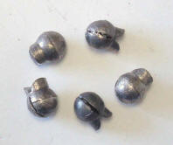
Only enough weight should be used to cast the bait and keep it at the desired depth (Figure 8). More weight will be needed in windy weather or swift water. To prevent losing a fish, weights should be attached carefully, especially when weights are on the fishing line directly between the hook and the angler.
Floats, Bobbers or Corks
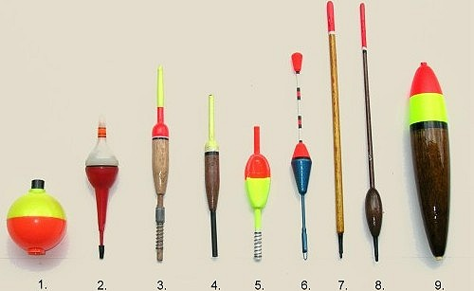
Floats keep baits off the bottom and assist with detecting a bite. The float should be just large enough to do the job. If the float is too large, the fish will feel it and may not become hooked.

Knots connect the fish and the angler.
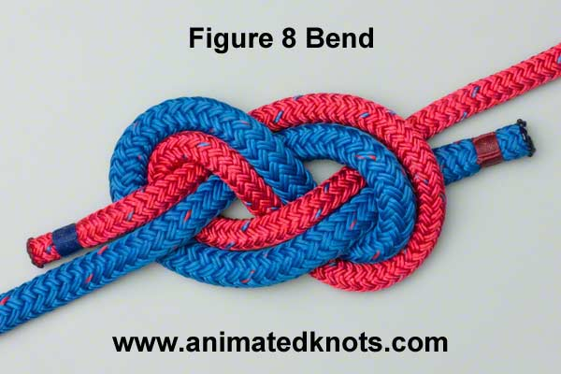
Tying quality knots is the single most important skill that should be learned. The knot that connects the hook or lure to the fishing line is the most important knot to learn. Several knots work well, such as the Improved Clinch, the Palomar, and the Duncan Loop knots (Figures 10-16). Anglers should try them all and pick a favorite knot. Anglers should then master the skill of tying their favorite knot.
The Improved Clinch Knot is a basic knot for anglers to use with monofilament line.
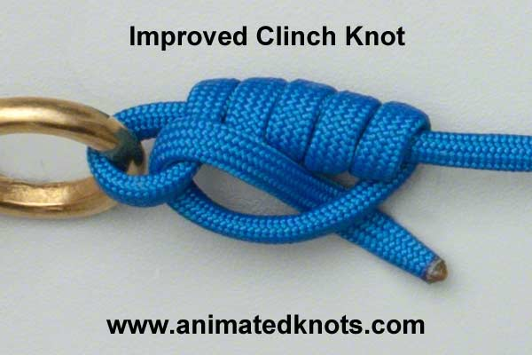
To tie an Improved Clinch Knot: (a) pass the line through the eye of the hook, then make several turns around the standing end of the line (more for lighter line); (b) pass the tag end through first loop above eye; (c) pass the tag end through the "big loop;" (d) moisten the line and slide tight against the eye.
For light lines, such as 6 pound test, six to eight turns is required; for heavier line (10 to 20 pound test), five or six turns works better.
The Palomar Knot is also a good knot for beginning anglers, as it is strong and easy to tie.
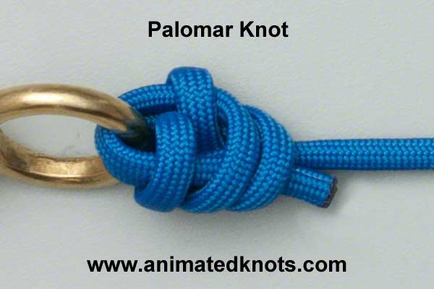
To tie a Palomar knot: (a) double about 4 inches of line and pass the loop through the hook eye; (b) tie an overhand knot with doubled line; (c) pass hook through line loop; and (d) moisten the line and pull the knot tight.

The Surgeon’s End Loop is used to tie a loop at the end of a fishing line.
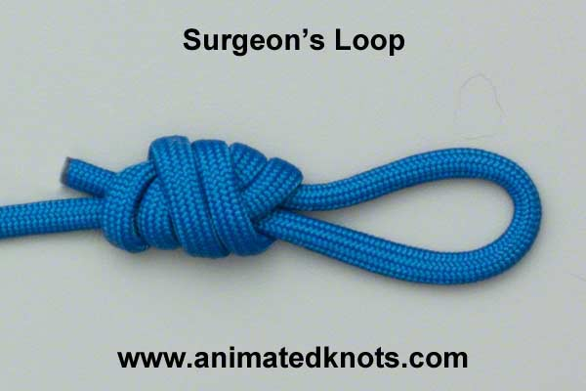
To tie a surgeon’s end loop: (a) double about 4 inches of line and tie an overhand knot with it; (b) bring doubled end through the loop once again; and (c) moisten the line, hold both the standing end and tag end, and pull loop to tighten knot.
The Arbor Knot is used to tie fishing line to a reel.
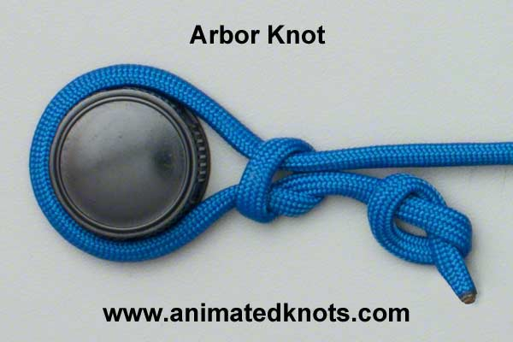
To tie an arbor knot: (a) thread the line through all the rod's line guides, around the spool and back
out the guide; (b) tie an overhand knot at the end of the tag end; (c) tie an overhand knot with the tag end that has the main line running through the hole;(d) tighten both knots and pull standing end until knot is snug against spool.
The Surgeon's Knot and the Barrel Knot are used to join two lines together. The surgeon's knot is preferred when tying two lines of unequal diameter.
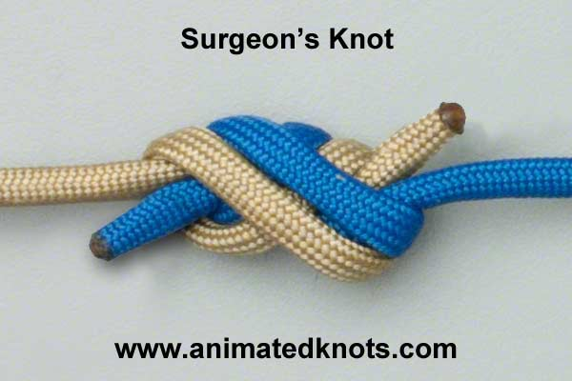
To tie a Surgeon's Knot: (a) lay the two lines parallel, overlapping about 6 inches; (b) as though the two were a single line, tie an overhand knot, pulling the entire leader through the loop; (c) pull both tag end of line and leader through again. (d) Moisten line and pull to tighten.

Rigging is how the bait is hooked and where the hook, snap or swivel, weight and float are used.
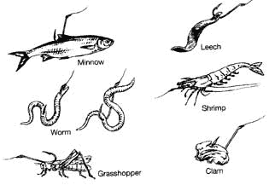
The type rig that catches the most fish is the best rig.
